1. Infrastructure Requirements

A. Location & Layout
- Pharmacy should be:
  - Easily accessible from OPD/IPD
  - Separate from general stores and patient waiting areas
- Minimum functional areas:
  - Dispensing Area
  - Storage Area
  - Compounding / Preparation Area (if in-house preparation is planned)
  - Administrative / Record Area

B. Space & Structure
- Adequate floor space (no congestion)
- Smooth, washable floors and walls
- Proper ventilation and lighting
- Pest-free environment
- Clean water supply and drainage

C. Furniture & Equipment
- Dispensing counter with writing space
- Lockable storage cupboards
- Racks/shelves (preferably stainless steel or laminated)
- Refrigerator (2–8°C) for temperature-sensitive drugs
- Weighing balance (calibrated)
- Measuring cylinders, spoons, mortars (if compounding)
- Fire extinguisher

2. Storage of Ayurveda Medicines 💊

A. General Storage Principles
- Store medicines:
  - In a cool, dry place
  - Away from direct sunlight and moisture
- Maintain room temperature (below 25–30°C)
- Good air circulation

B. Segregation of Medicines
Medicines should be systematically arranged:
- By dosage form:
  - Churna
  - Vati/Gutika
  - Asava–Arishta
  - Taila–Ghrita
  - Avaleha
- By internal vs external use
- By alphabetical order or formulation group

C. Special Storage Considerations
- Asava & Arishta:
  - Store in upright position
  - Tightly closed containers
- Taila & Ghrita:
  - Away from heat
  - Protect from oxidation
- Powders (Churna):
  - Moisture-proof containers
- Refrigeration:
  - Certain eye drops, liquid preparations (if specified)

D. Stock Control
- FIFO (First In First Out)
- FEFO (First Expiry First Out)
- Regular stock verification
- Separate area for:
  - Expired medicines
  - Damaged/returned stock

3. Dispensing Practices (Ayurvedic Hospital Pharmacy)

A. Prescription Handling
- Dispense medicines only against valid prescription
- Verify:
  - Patient name, age, diagnosis
  - Drug name, dose, duration
- Clarify illegible or incomplete prescriptions with physician

B. Labeling Requirements
Each dispensed medicine should have:
- Name of medicine
- Dose and frequency
- Duration of therapy
- Method of administration (before/after food)
- Storage instructions
- Hospital/pharmacy name

C. Patient Counseling
Explain clearly:
- Method of intake (Anupana – water, milk, honey, etc.)
- Timing related to meals
- Duration and importance of adherence
- Precautions and contraindications
- Storage at home

D. Hygiene & Safety
- Hand hygiene before dispensing
- Clean dispensing area
- No eating/drinking in pharmacy
- Avoid cross-contamination during dispensing

4. Personnel Requirements 👨‍⚕️
- Qualified Ayurvedic Pharmacist (D.Pharm Ayurveda / B.Pharm Ayurveda as per local rules)
- Supporting staff trained in:
  - Drug handling
  - Basic record maintenance
- Continuous training on Good Pharmacy Practices

5. Records & Documentation 📁
Mandatory records:
- Purchase records (invoice, batch no.)
- Stock register
- Dispensing register (OPD/IPD)
- Expiry & breakage register
- Refrigerator temperature log
- Cleaning & pest control log

6. Regulatory & Legal Compliance 📜
- Pharmacy should comply with guidelines issued by Ministry of AYUSH
- Use medicines manufactured under GMP-certified units
- Display:
  - Pharmacy license
  - Name & registration of pharmacist
- Follow Drugs & Cosmetics Act (Ayurvedic section)

A. Standard Floor Layout (Recommended)
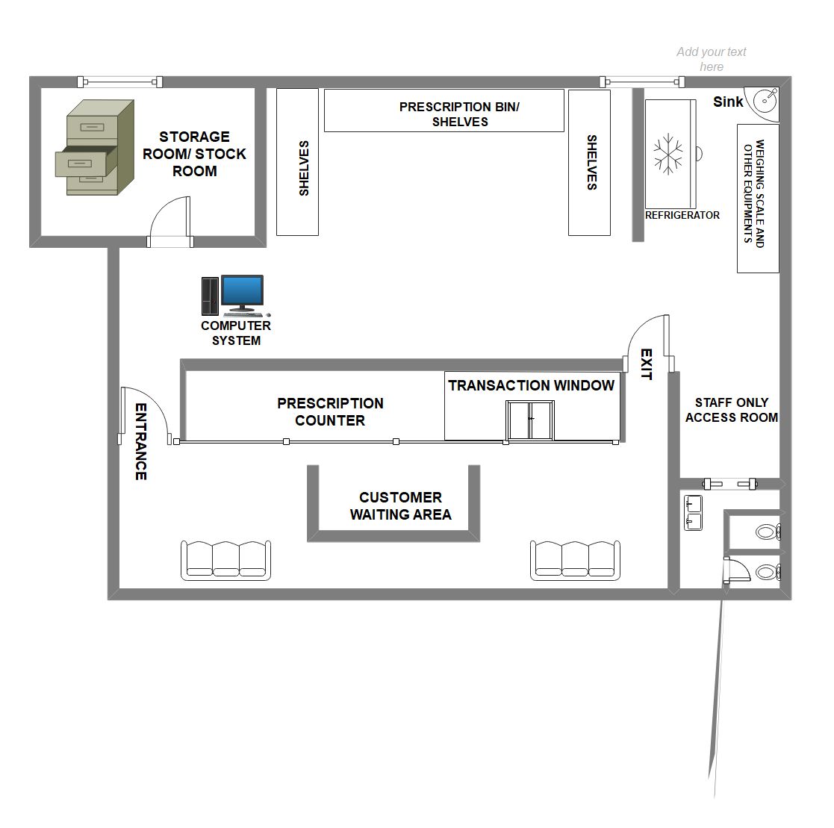

🧱 Suggested Total Area
- 300–500 sq ft (can be adjusted based on hospital size)

B. Zonal Layout (Functional Segregation)
--------------------------------------------------
| STORAGE AREA (40–45%) |
| - Racks for medicines |
| - FEFO/FIFO arrangement |
| - Refrigerator (corner) |
| - High-risk / Look-alike drugs separate |
--------------------------------------------------
| COMPOUNDING / PREPARATION (15–20%) | RECORDS |
| - Weighing balance | (5–10%) |
| - Mortar, measuring jars | |
| - Wash basin | |
--------------------------------------------------
| DISPENSING & COUNSELING (25–30%) |
| - Counter facing patient area |
| - Labeling space |
| - Patient counseling window |
--------------------------------------------------
| PATIENT SIDE / OPD ACCESS |
--------------------------------------------------

C. Area-wise Details

1️⃣ Dispensing & Counseling Area (Front Zone)
- Located nearest to OPD/IPD
- One or two dispensing windows
- Counter height: ~1.1–1.2 m
- Space for:
  - Prescription checking
  - Labeling
  - Patient instructions
- Display:
  - Pharmacy license
  - Pharmacist registration
  - Working hours

2️⃣ Storage Area (Back / Restricted Access)
- Restricted to pharmacy staff only
- Open racks with labeling:
  - Churna
  - Vati / Gutika
  - Asava–Arishta
  - Taila–Ghrita
  - Avaleha
- Separate shelves for:
  - Internal vs external medicines
  - Expired / quarantined stock
- Refrigerator:
  - Away from sunlight
  - With temperature log display

3️⃣ Compounding / Preparation Area
(Only if in-house preparation or repacking is planned)
- Physically separated (partition)
- Wash basin with potable water
- Weighing balance on vibration-free table
- Dedicated utensils (not shared with storage)
- Easy-to-clean surfaces

4️⃣ Records & Administrative Corner
- Stock registers
- Purchase bills
- Expiry records
- Computer (optional but recommended)
- Lockable cupboard

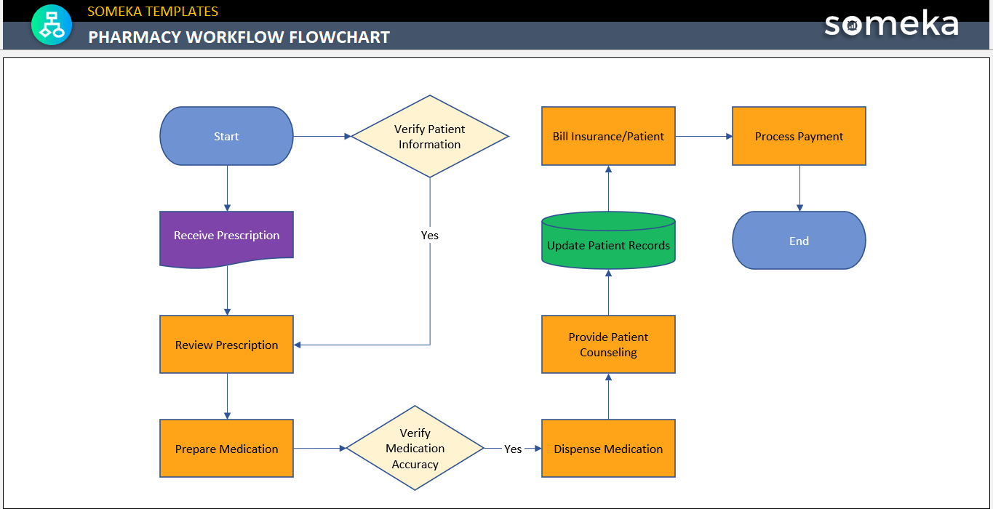

NABH-Required Signage & Visual Controls

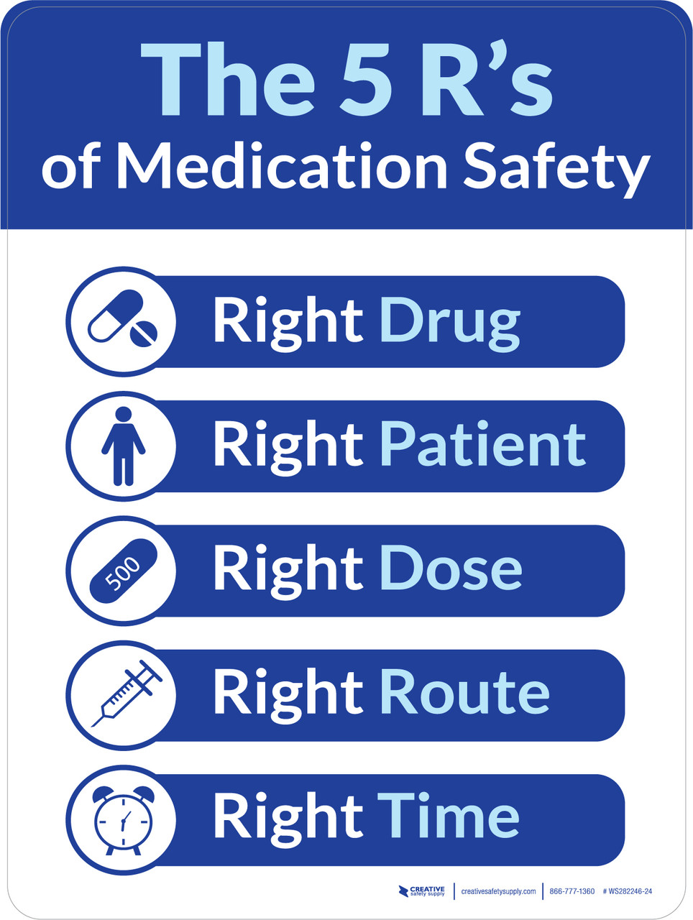

- Clean / Restricted Area markings
- LASA drugs signage
- Expired & Quarantine labels
- Hand hygiene posters
- Fire safety instructions

